Bean validation and Registration in the given EmployeeManagement CRUD project

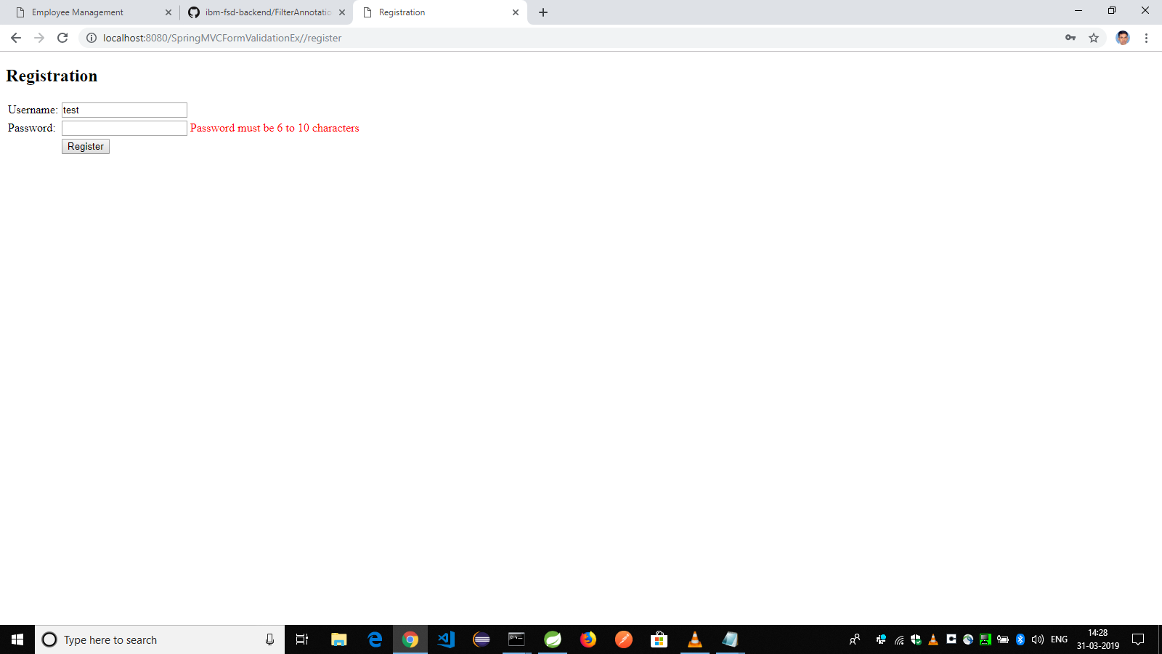

Registration success

